Week 1

Code

import numpy as np
a = np.arange(68)
print("vector a:", a)
a_2d = a.reshape(1, -1)
print("\n2D Array with 1 row:\n", a_2d)
b = a_2d.copy()
print("\ncopied array:\n", b)
print("\nShape of array b:", b.shape)

Output

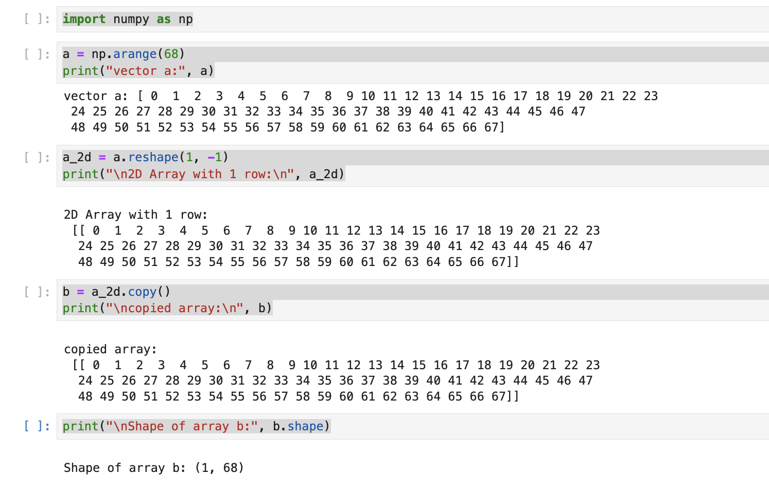

Week 2

Code
import pandas as pd

data = pd.DataFrame({
"relationship": ["Husband", "Wife", "Not-in-family", "Own-child", "Husband", "Wife"],
"hours-per-week": [40, 50, 60, 20, 55, 45]
})

n = 8

def reduce_hours(x):
return x - n

data["reduced_hours"] = data["hours-per-week"].apply(reduce_hours)

grouped = data.groupby(["relationship", "reduced_hours"]).size().reset_index(name="count")

print("Original DataFrame:")
print(data, "\n")

print("Grouped DataFrame:")
print(grouped)

Output

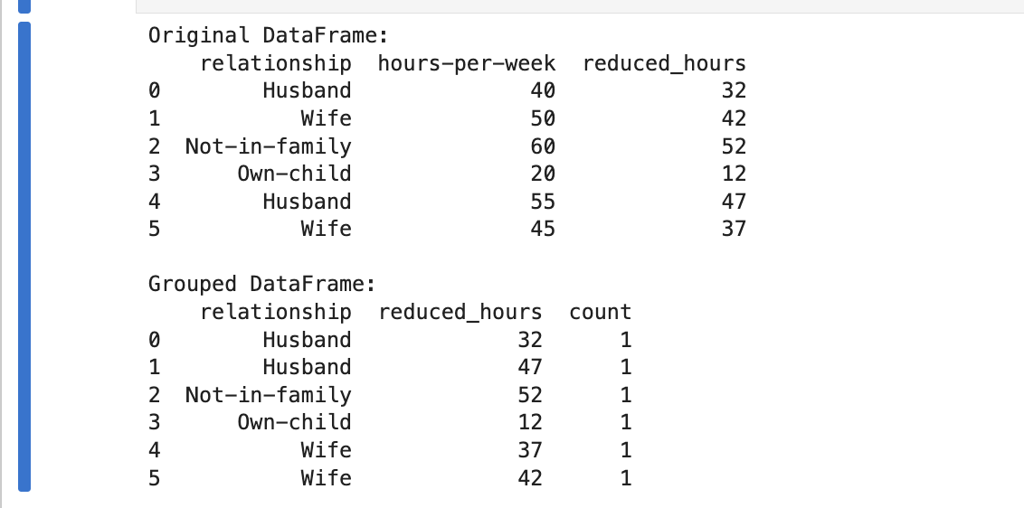

Week 3

Code

import os
print(os.getcwd())

import pandas as pd

file_path = "/Users/srinivas/Downloads/telecom_churn.csv"
data = pd.read_csv(file_path)

print("CSV loaded successfully!")
print(data.head())

import pandas as pd
import matplotlib.pyplot as plt

# Load dataset
df = pd.read_csv("telecom_churn.csv")

# Correct column names (case-sensitive)
x = df['Total night calls']
y = df['Total intl calls']
churn_col = 'Churn'

# Create bicolour scatter plot
plt.figure(figsize=(8,6))
plt.scatter(x[df[churn_col] == False], y[df[churn_col] == False],
color='blue', label='Not Churned', alpha=0.6)
plt.scatter(x[df[churn_col] == True], y[df[churn_col] == True],
color='red', label='Churned', alpha=0.6)

plt.title('Bicolour Feature Interaction: Total Night Calls vs Total Intl Calls')
plt.xlabel('Total Night Calls')
plt.ylabel('Total Intl Calls')
plt.legend()
plt.grid(True)
plt.show()

Output

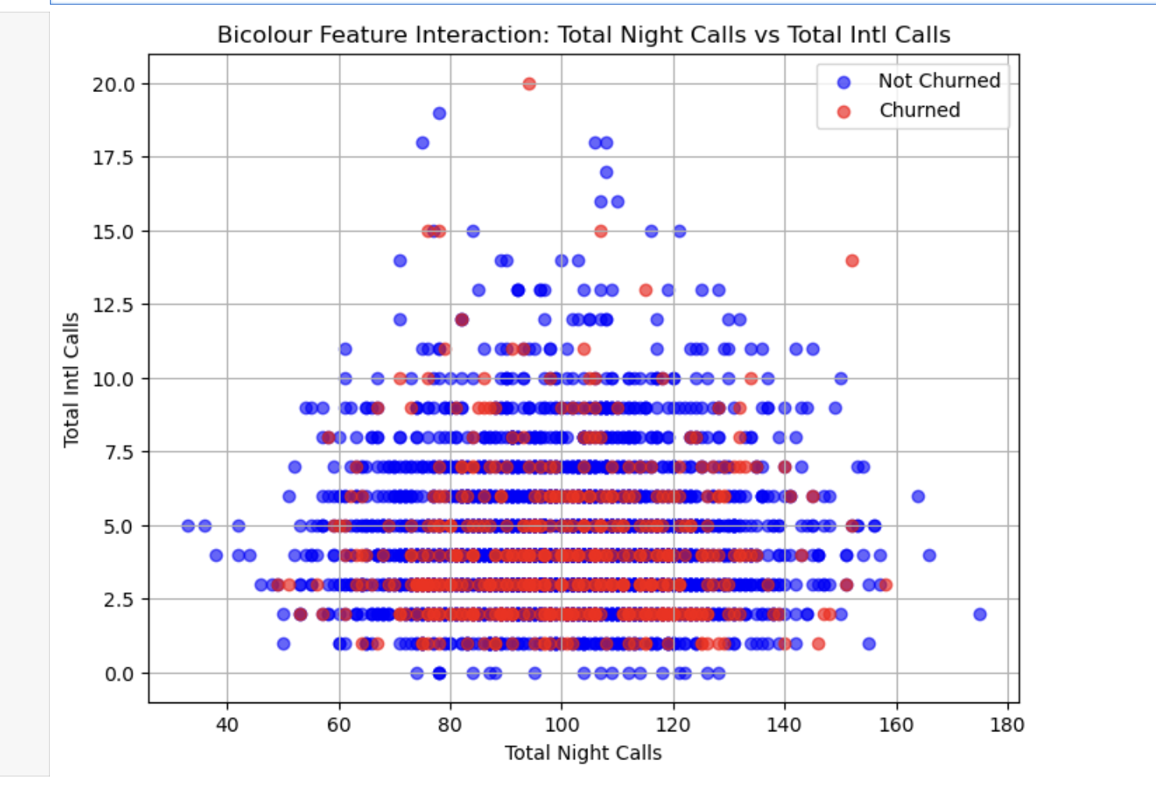
WEEK 4

CODE

import tensorflow as tf
from tensorflow.keras.models import Sequential
from tensorflow.keras.layers import Dense
from tensorflow.keras.optimizers import Adam

model_custom = Sequential([
Dense(968, activation='relu', input_shape=(X_train.shape[1],)),
Dense(484, activation='relu'),
Dense(1, activation='linear')
])

model_custom.compile(
optimizer=Adam(learning_rate=0.001), # same as practical session
loss='mae',
metrics=['mae']
)

print("\n Model Architecture Summary:")
model_custom.summary()

print("\n Training the model...")
history_custom = model_custom.fit(
X_train, y_train,
validation_data=(X_test, y_test),
epochs=10,
batch_size=32,
verbose=1
)

test_loss, test_mae = model_custom.evaluate(X_test, y_test, verbose=0)
print("\n Mean Absolute Error (MAE) on Test Dataset:", round(test_mae, 4))

previous_mae = 0.0123

print("\n Comparison:")
print(f" - Previous MLP MAE: {previous_mae}")
print(f" - My MLP (SID 2435968): {round(test_mae, 4)}")

OUTPUT

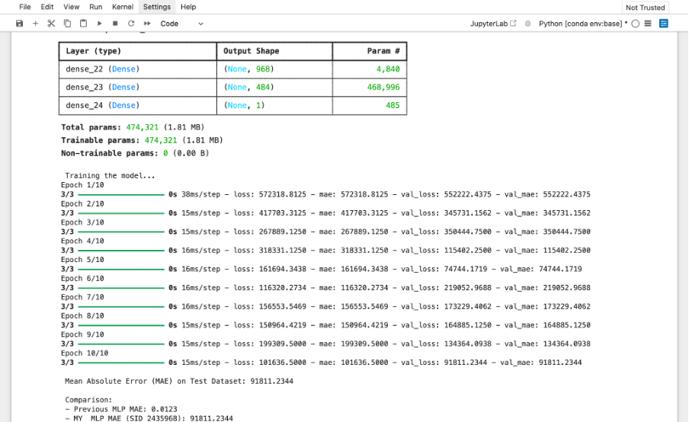

WEEK 5

import tensorflow as tf
from tensorflow import keras
import numpy as np

model = keras.Sequential([
keras.Input(shape=(50, 5)),
keras.layers.Conv1D(50, 5, padding='same', activation='relu', kernel_initializer="normal"),
keras.layers.MaxPooling1D(7),
keras.layers.Conv1D(100, 7, padding='same', activation='relu', kernel_initializer="normal"),
keras.layers.GlobalMaxPooling1D(),
keras.layers.Dense(25, activation='relu', kernel_initializer="normal"),
keras.layers.Dense(2)
])

model.compile(optimizer='adam', loss='mse', metrics=['mae'])
model.summary()

X_train, y_train, X_test, y_test = map(np.array, [X_train, y_train, X_test, y_test])

min_len_train = min(len(X_train), len(y_train))
min_len_test = min(len(X_test), len(y_test))

X_train, y_train = X_train[:min_len_train], y_train[:min_len_train]
X_test, y_test = X_test[:min_len_test], y_test[:min_len_test]

X_train = X_train.reshape(-1, 50, 5)
X_test = X_test.reshape(-1, 50, 5)
y_train = y_train.reshape(-1, 2)
y_test = y_test.reshape(-1, 2)

history = model.fit(
X_train, y_train,
epochs=14,
batch_size=50,
validation_data=(X_test, y_test),
verbose=1
)

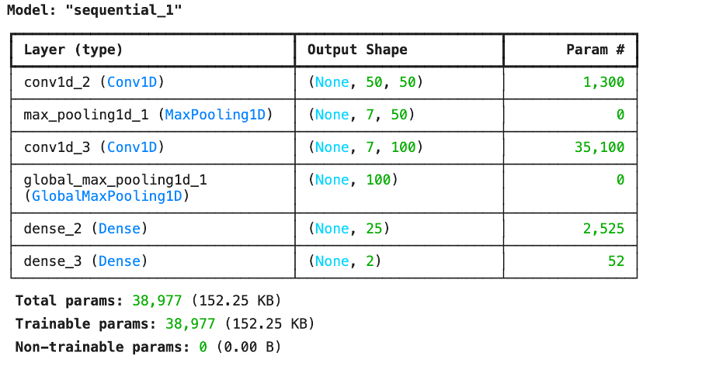
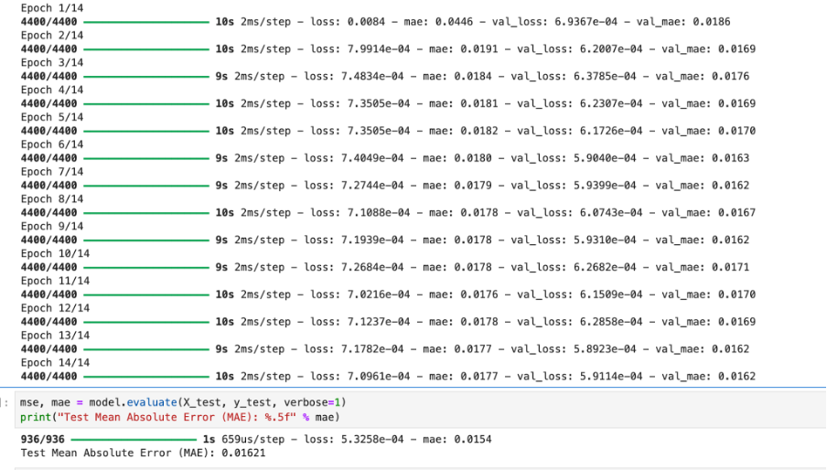

Week 6
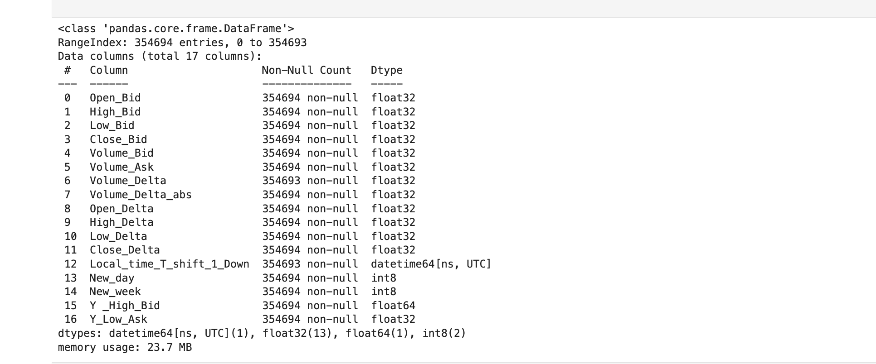

Code

import pandas as pd
import cufflinks as cf
cf.go_offline()

data2 = pd.read_csv('GOLD_2022_normalised.csv')

for col in data2.columns:
try:
data2[col] = pd.to_numeric(data2[col])
except:
pass

numeric_cols = data2.select_dtypes(include='number').columns

min_price = data2[numeric_cols].min().min()
max_price = data2[numeric_cols].max().max()

data2[numeric_cols] = (data2[numeric_cols] - min_price) / (max_price - min_price)

data_part = data2.iloc[35968 : 35968 + 968]

data_part.rename(columns={'High_x': 'High_Bid', 'Low_x': 'Low_Bid'}, inplace=True)

data_part[['High_Bid', 'Low_Bid']].iplot(
title='GOLD Price Chart (High_Bid vs Low_Bid)',
xTitle='Time (UTC)',
yTitle='Normalized Price',
theme='solar'
)

Output

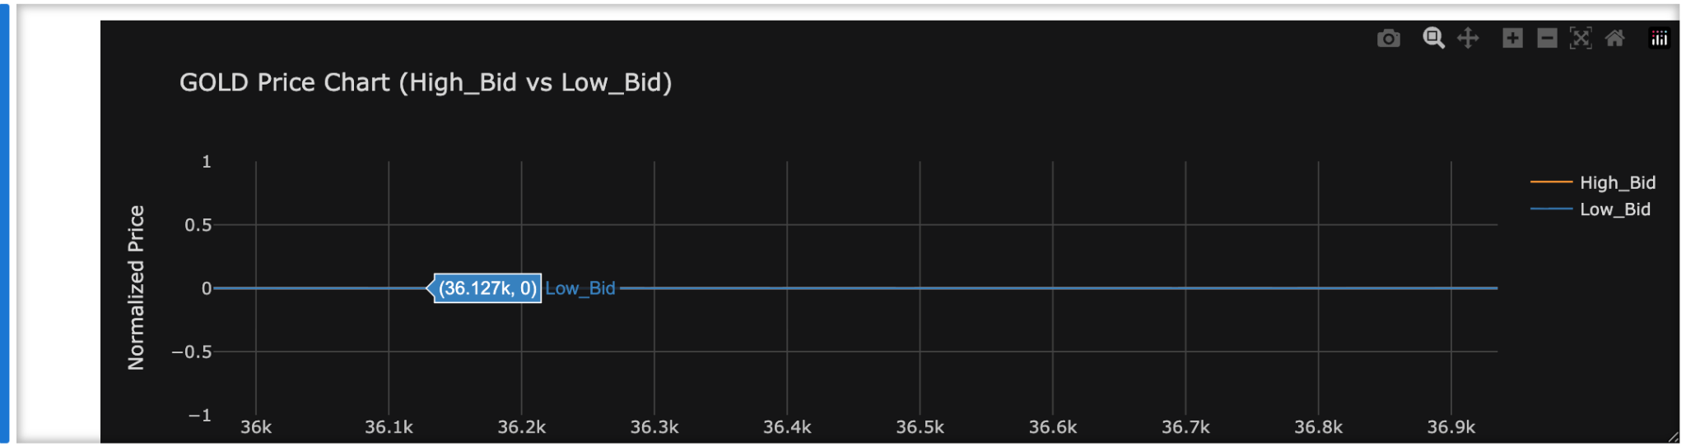

Week 7

CODE
model = keras.Sequential([
keras.layers.LSTM(78, activation='relu', input_shape=(50, 18)),
keras.layers.Dense(2)
])

print(model.summary())
model.compile(optimizer="adam", loss="mse", metrics=["mae"])
# Early Stopping parameters

es = EarlyStopping(monitor='val_loss', mode='min', patience=3, verbose=1)
mc = ModelCheckpoint('best_model_LSTM_GOLD.keras', monitor='val_loss', mode='min', verbose=1, save_best_only=True)
history = model.fit(
X_train, y_train,
batch_size=20,
epochs=10,
validation_split=0.1,
shuffle=True,
verbose=1,
callbacks=[es, mc]
)

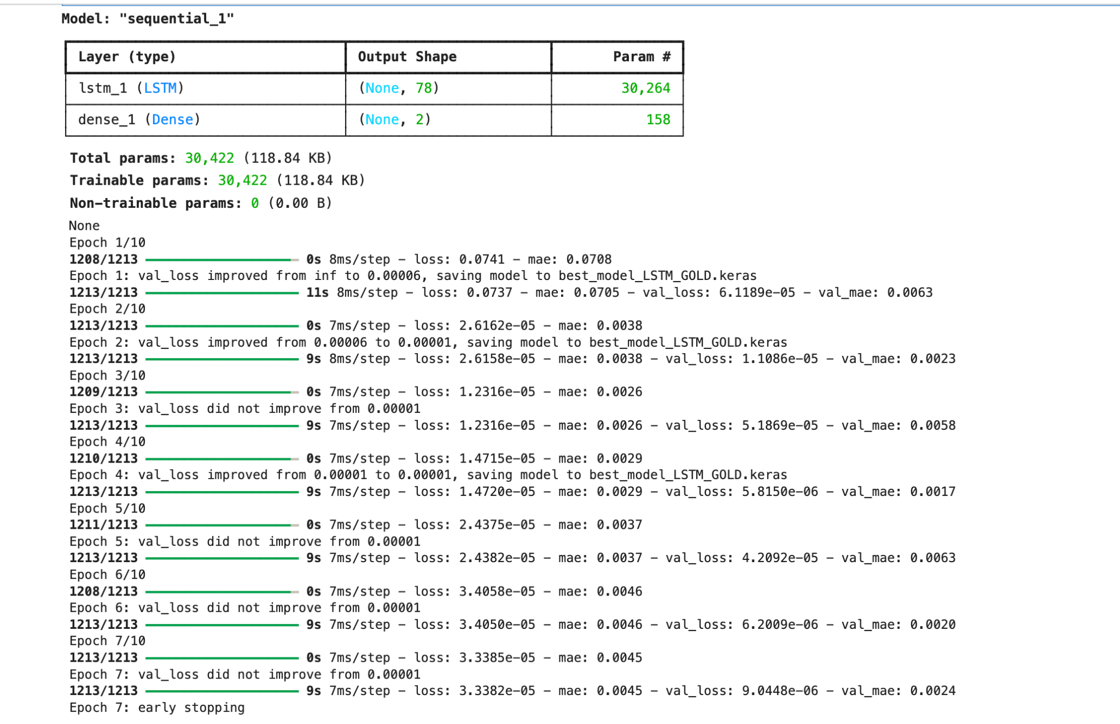
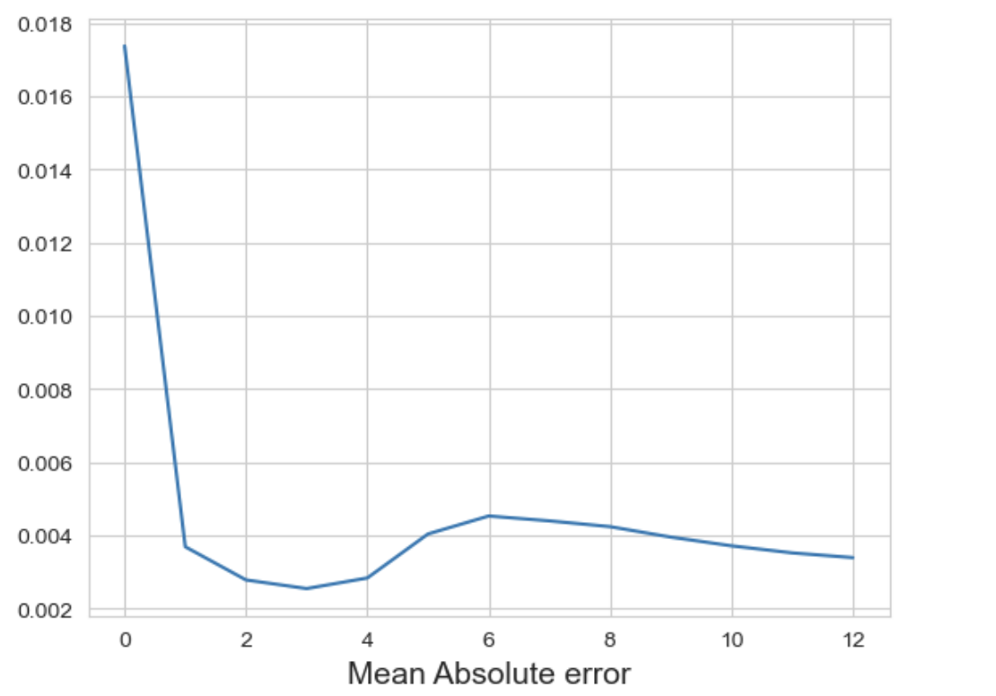

WEEK 8

